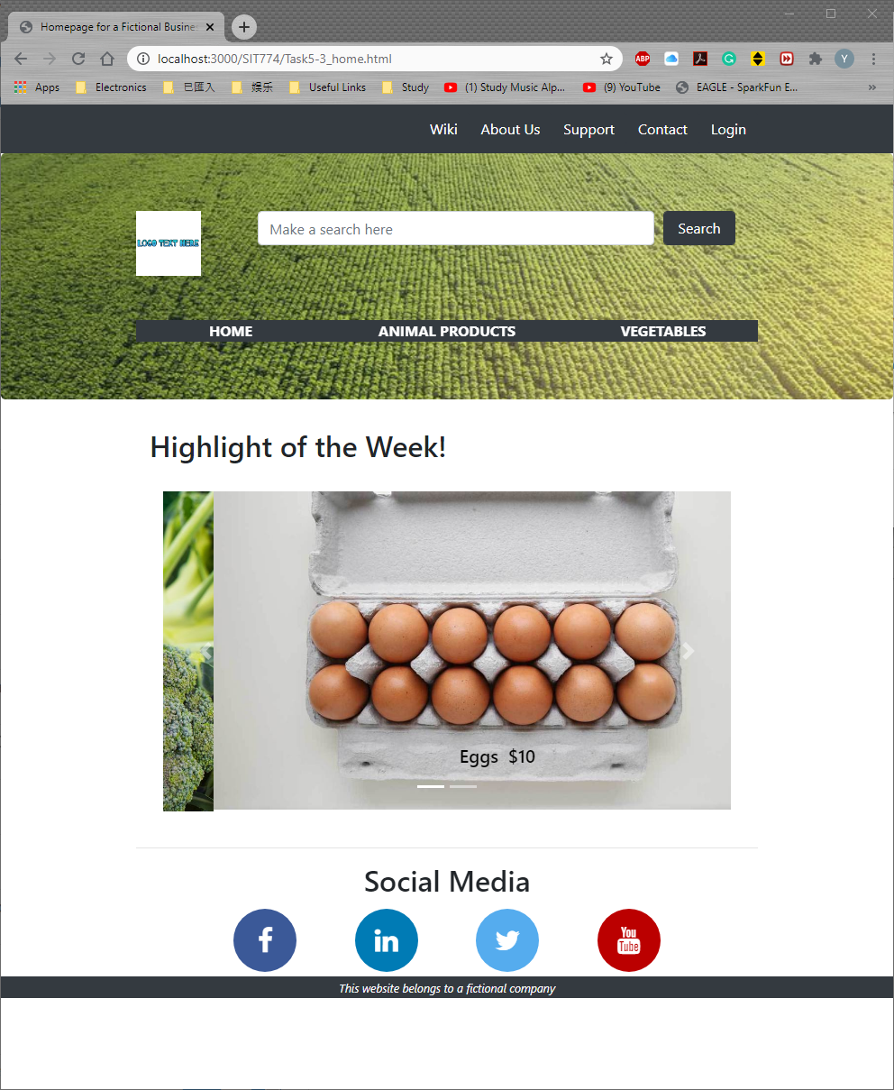

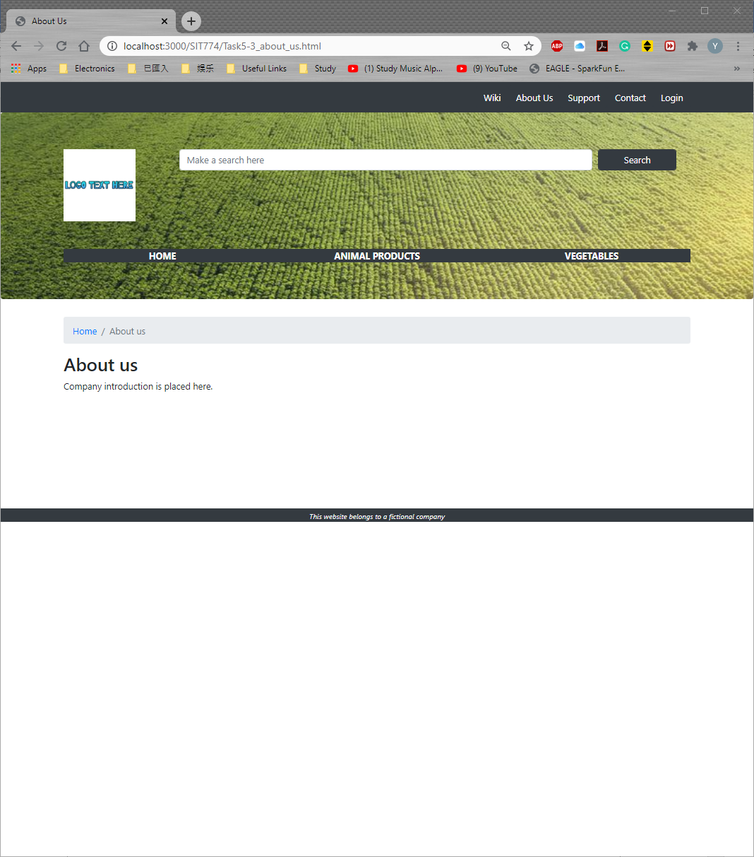

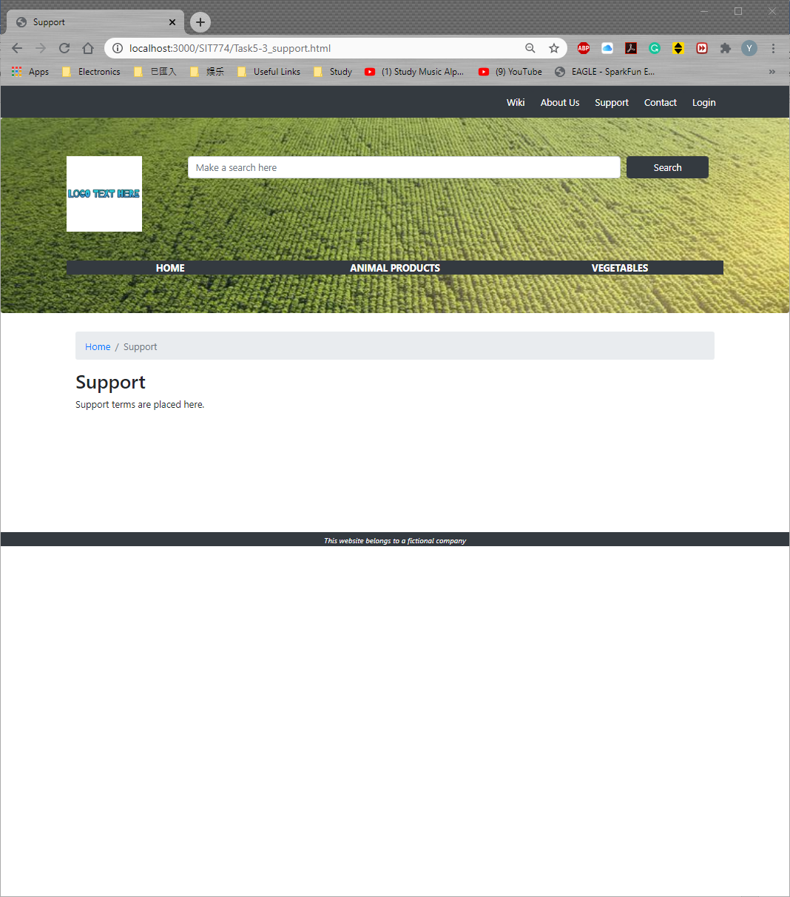

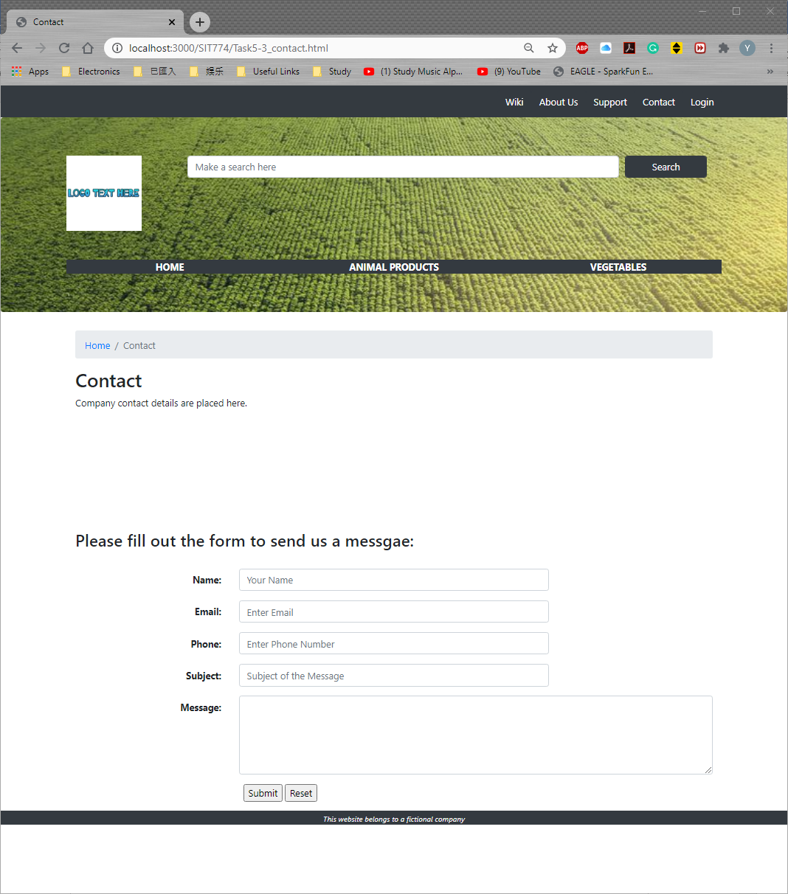

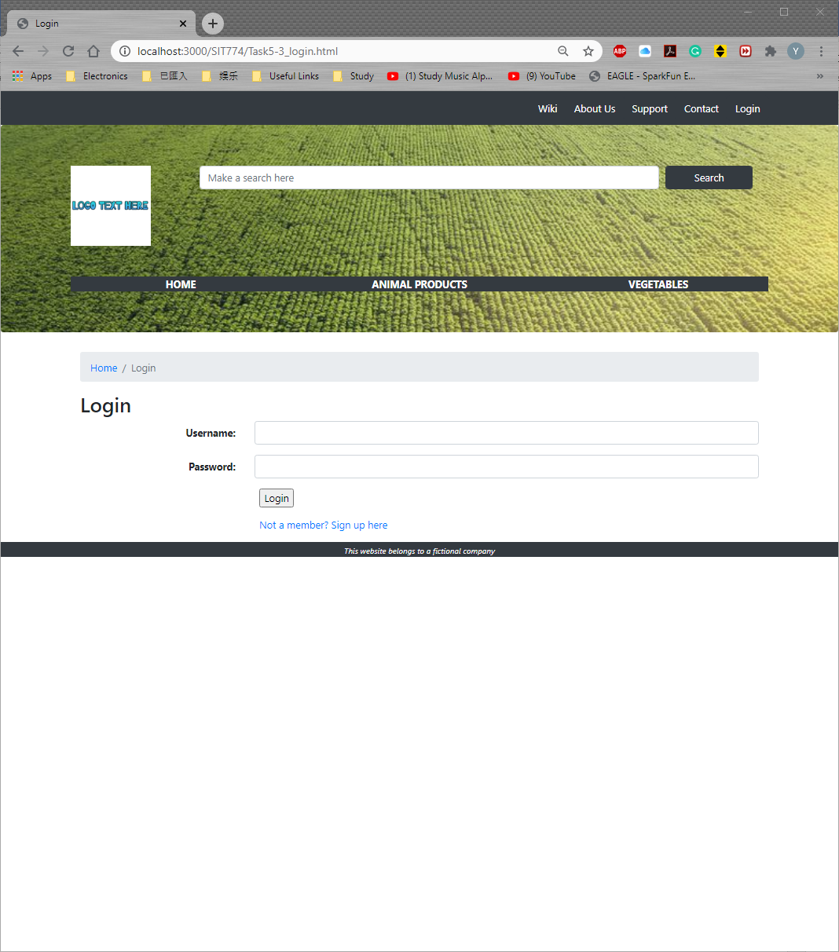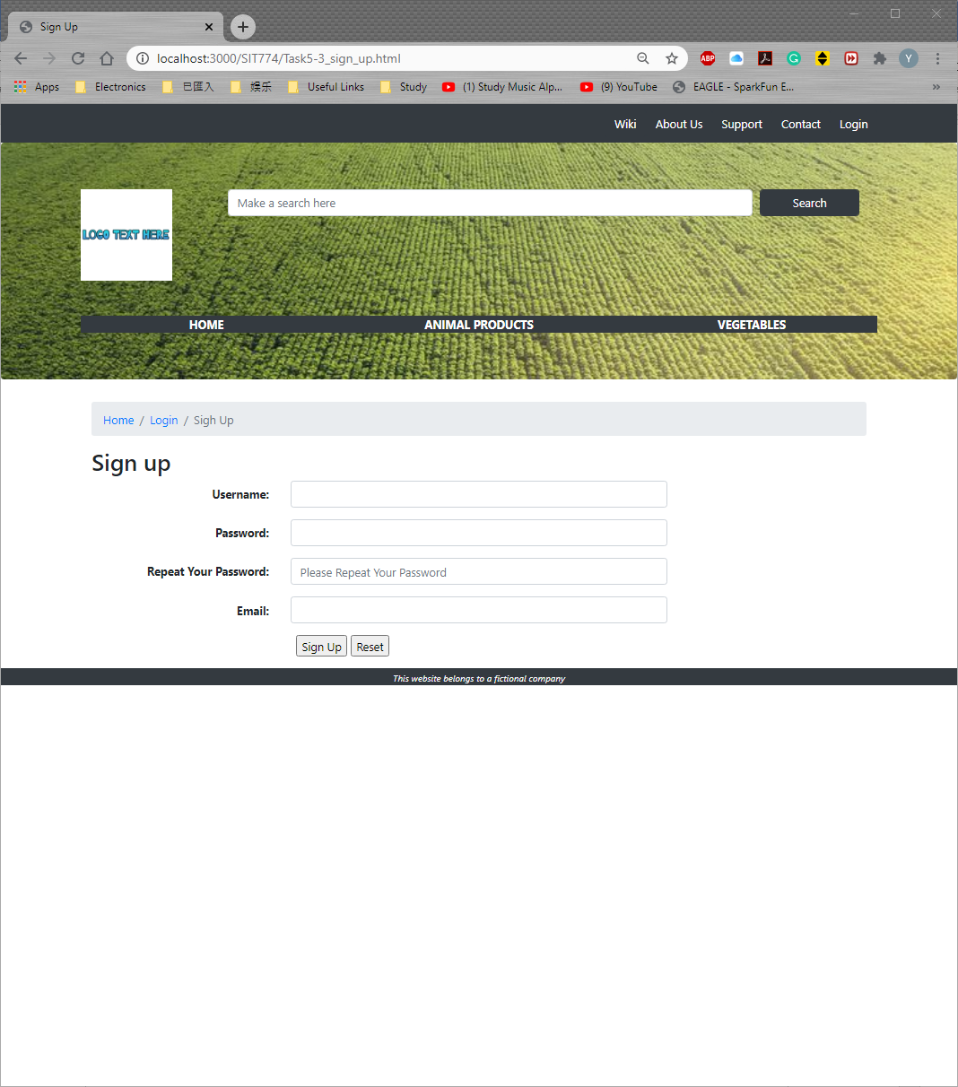

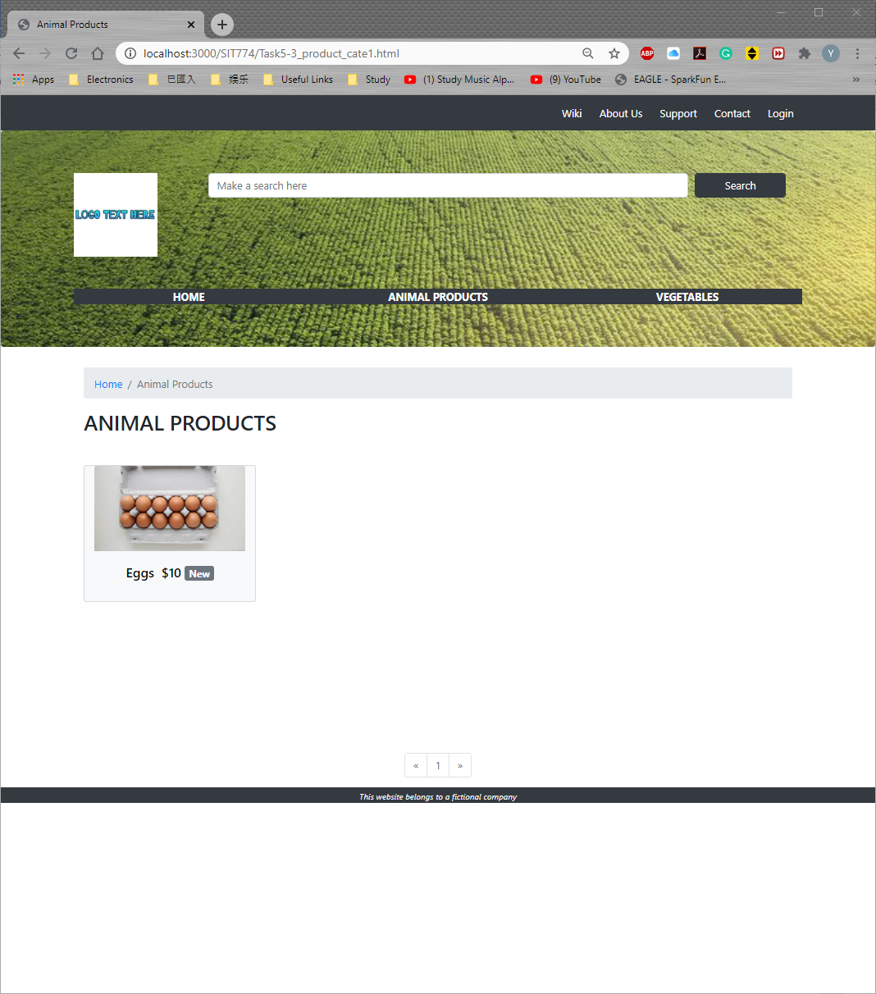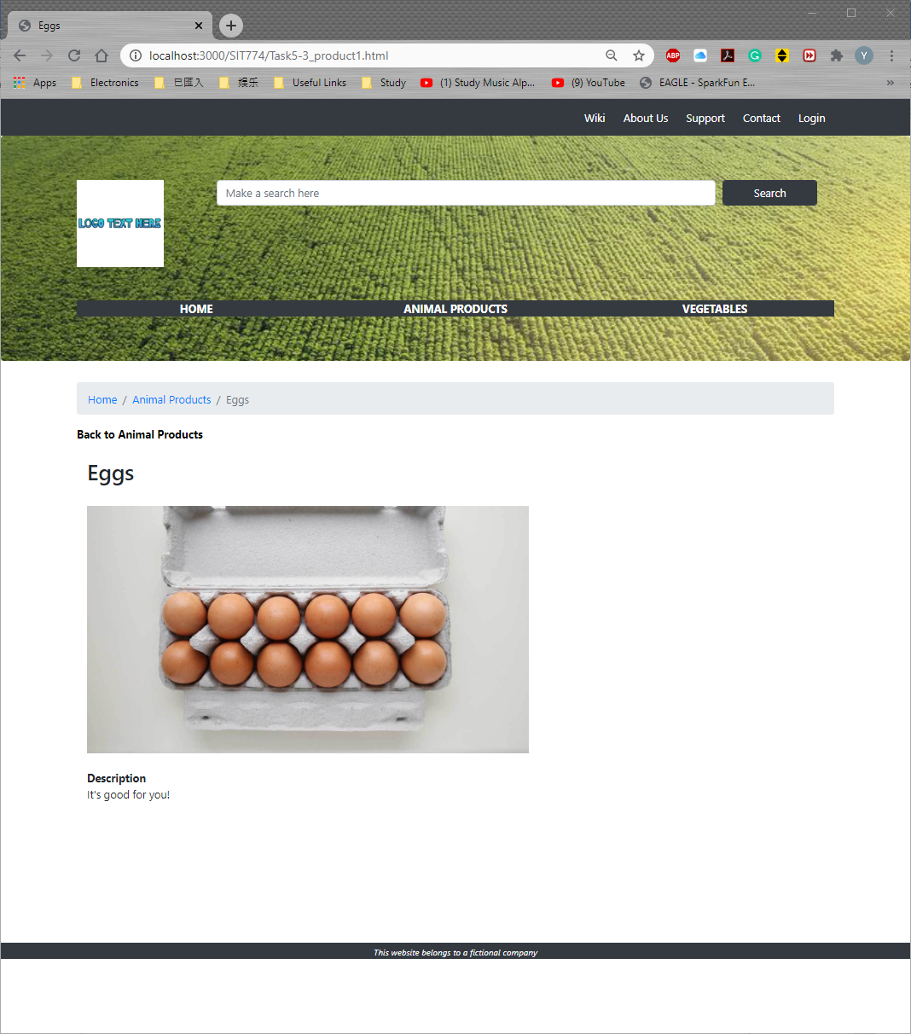

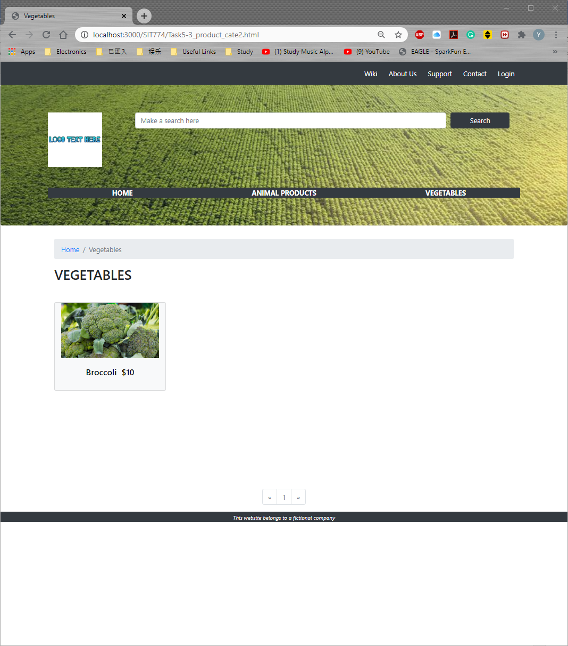

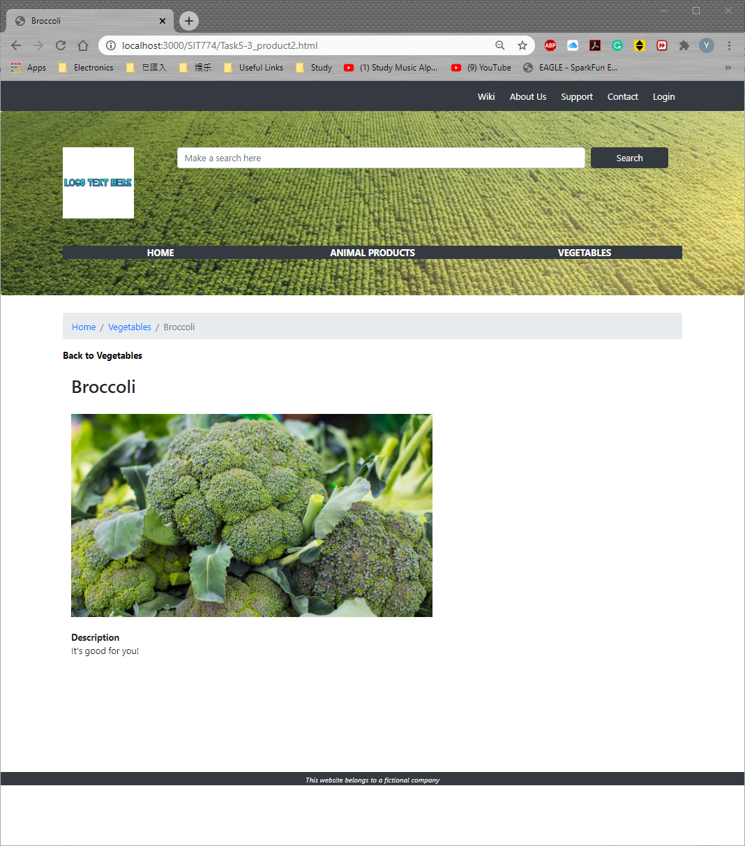

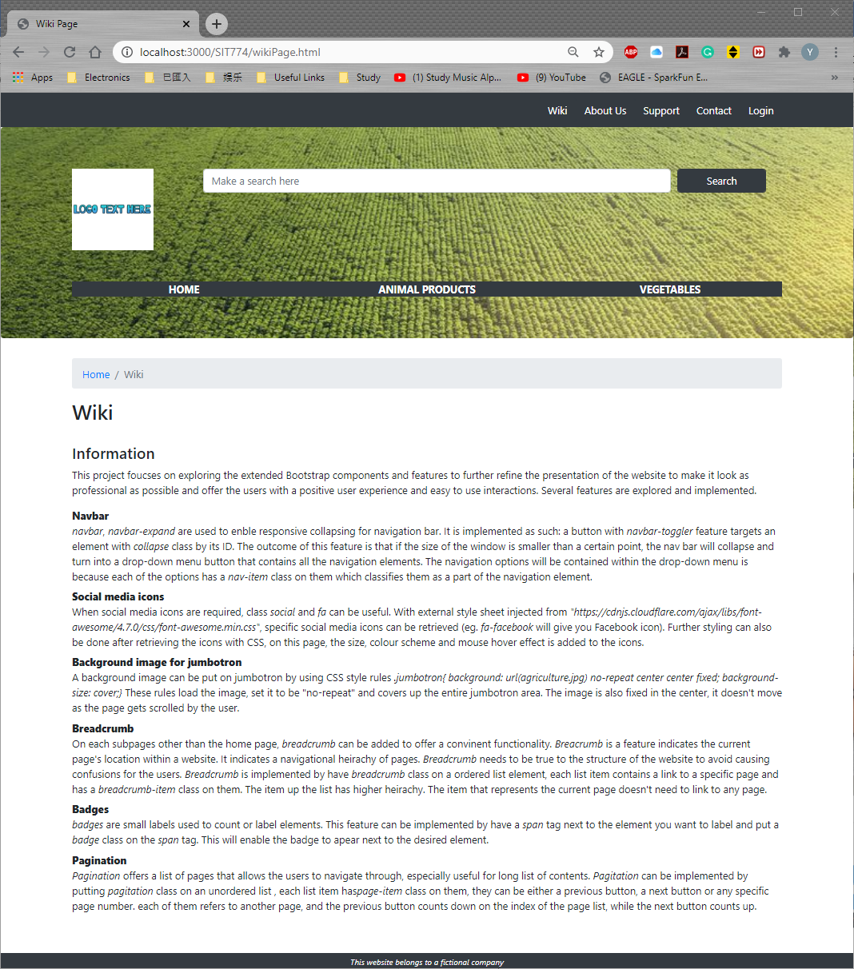

<!DOCTYPE html>

<html lang="en">

<!-- Here is the head element-->

<head>

    <title>Homepage for a Fictional Business</title>

    <meta name="author" content="Yiyang Hou">

    <meta name="description" content="Homepage for a Fictional Business">

    <meta charset="utf-8">

    <meta name="viewport" content="width=device-width, initial-scale=1, shrink-to-fit=no">

    <!-- Latest compiled and minified CSS -->

    <link rel="stylesheet" href="https://stackpath.bootstrapcdn.com/bootstrap/4.5.0/css/bootstrap.min.css"

        integrity="sha384-9aIt2nRpC12Uk9gS9baDl411NQApFmC26EwAOH8WgZl5MYYxFfc+NcPb1dKGj7Sk" crossorigin="anonymous">

    <link rel="stylesheet" href="https://cdnjs.cloudflare.com/ajax/libs/font-awesome/4.7.0/css/font-awesome.min.css">

    <link rel="stylesheet" href="project.css">

</head>

<body>

    <nav class="navbar navbar-expand-md navbar-dark bg-dark">

        <div class="container">

            <button class="navbar-toggler" type="button" data-toggle="collapse" data-target="#navbarResponsive">

                <span class="navbar-toggler-icon"></span>

            </button>

            <div class="collapse navbar-collapse" id="navbarResponsive">

                <ul class="navbar-nav ml-auto">

                    <li class="nav-item">

                        <a class="btn btn-dark" href="wikiPage.html" role="button">Wiki</a>

                    </li>

                    <li class="nav-item">

                        <a class="btn btn-dark" href="Task5-3_about_us.html" role="button">About Us</a>

                    </li>

                    <li class="nav-item">

                        <a class="btn btn-dark" href="Task5-3_support.html" role="button">Support</a>

                    </li>

                    <li class="nav-item">

                        <a class="btn btn-dark" href="Task5-3_contact.html" role="button">Contact</a>

                    </li>

                    <li class="nav-item">

                        <a class="btn btn-dark" href="Task5-3_login.html" role="button">Login</a>

                    </li>

                </ul>

            </div>

        </div>

    </nav>

    <!-- Header part of the page within jumbotron -->

    <div class="jumbotron">

        <div class="container">

            <div class="row">

                <div class="col-md-2">

                    <img src="logo.png" alt="Logo" style="width: 80%;">

                </div>

                <!-- Some navigation options at the top -->

                <div class="col-md-10 text-center font-weight-bold">

                    <form>

                        <!-- A search feature -->

                        <div class="form-row container">

                            <div class="col-md-10 col-12">

                                <input type="text" class="form-control" name="searchbox" id="searchbox"

                                    placeholder="Make a search here">

                            </div>

                            <div class="col-md-2 font-weight-bold">

                                <input type="submit" class="form-control btn btn-dark" value="Search">

                            </div>

                        </div>

                    </form>

                </div>

            </div>

            <hr style="height: 1em;">

            <!-- Navigation of the site -->

            <nav class="bg-dark sticky-top">

                <div class="row">

                    <div class="col-md-4 font-weight-bold text-center">

                        <a href="Task5-3_home.html" role="button" style="color: white;">HOME</a>

                    </div>

                    <div class="col-md-4 font-weight-bold text-center">

                        <a href="Task5-3_product_cate1.html " role="button" style="color: white;">ANIMAL PRODUCTS</a>

                    </div>

                    <div class="col-md-4 font-weight-bold text-center">

                        <a href="Task5-3_product_cate2.html" role="button" style="color: white;">VEGETABLES</a>

                    </div>

                </div>

            </nav>

        </div>

    </div>

    <!-- Homepage Content Section -->

    <div class="container">

        <div class="col-md-12">

            <h2>Highlight of the Week!</h2>

            <br>

            <div class="container">

                <div id="newCarousel" class="carousel slide" data-ride="carousel">

                    <!--Indicators-->

                    <ol class="carousel-indicators">

                        <li data-target="#newCarousel" data-slide-to="0" class="active"></li>

                        <li data-target="#newCarousel" data-slide-to="1"></li>

                    </ol>

                    <!-- Wrapper for slides -->

                    <div class="carousel-inner">

                        <div class="carousel-item active">

                            <a href="Task5-3_product1.html" style="color: black;">

                                <img src="eggs.jpg" alt="Eggs" style="width:100%;">

                                <div class="carousel-caption font-weight-bold">

                                    <h5 style="color: black;">

                                        Eggs&nbsp;&nbsp;$10

                                    </h5>

                                </div>

                            </a>

                        </div>

                        <div class="carousel-item">

                            <a href="Task5-3_product2.html" style="color: black;">

                                <img src="broccoli.jpg" alt="Broccoli" style="width:100%;">

                                <div class="carousel-caption font-weight-bold">

                                    <h5>

                                        Broccoli&nbsp;&nbsp;$10

                                    </h5>

                                </div>

                            </a>

                        </div>

                    </div>

                    <!-- Left and right controls -->

                    <a class="carousel-control-prev" href="#newCarousel" data-slide="prev">

                        <span class="carousel-control-prev-icon"></span>

                        <span class="sr-only">Previous</span>

                    </a>

                    <a class="carousel-control-next" href="#newCarousel" data-slide="next">

                        <span class="carousel-control-next-icon"></span>

                        <span class="sr-only">Next</span>

                    </a>

                </div>

            </div>

        </div>

        <br>

        <!-- Social Media Section -->

        <hr>

        <div class="container-fluid padding">

            <div class="row text-center padding">

                <div class="col-12">

                    <h2>Social Media</h2>

                </div>

                <div class="col-12 social padding">

                    <a href="https://www.facebook.com" class="fa fa-facebook"></a>

                    <a href="https://www.linkedin.com" class="fa fa-linkedin"></a>

                    <a href="https://www.twitter.com" class="fa fa-twitter"></a>

                    <a href="https://www.youtube.com" class="fa fa-youtube"></a>

                </div>

            </div>

        </div>

    </div>

    <!-- footer -->

    <footer>

        <div class="container-fluid padding bg-dark text-center">

            <small class="text-light"><i> This website belongs to a fictional company</i></small>

        </div>

    </footer>

    <!-- Optional JavaScript -->

    <!-- jQuery first, then Popper.js, then Bootstrap JS -->

    <script src="https://code.jquery.com/jquery-3.5.1.slim.min.js"

        integrity="sha384-DfXdz2htPH0lsSSs5nCTpuj/zy4C+OGpamoFVy38MVBnE+IbbVYUew+OrCXaRkfj"

        crossorigin="anonymous"></script>

    <script src="https://cdn.jsdelivr.net/npm/popper.js@1.16.0/dist/umd/popper.min.js"

        integrity="sha384-Q6E9RHvbIyZFJoft+2mJbHaEWldlvI9IOYy5n3zV9zzTtmI3UksdQRVvoxMfooAo"

        crossorigin="anonymous"></script>

    <script src="https://stackpath.bootstrapcdn.com/bootstrap/4.5.0/js/bootstrap.min.js"

        integrity="sha384-OgVRvuATP1z7JjHLkuOU7Xw704+h835Lr+6QL9UvYjZE3Ipu6Tp75j7Bh/kR0JKI"

        crossorigin="anonymous"></script>

</body>

</html>

<!DOCTYPE html>

<html lang="en">

<!-- Here is the head element-->

<head>

    <title>About Us</title>

    <meta name="author" content="Yiyang Hou">

    <meta name="description" content="About Us">

    <meta charset="utf-8">

    <meta name="viewport" content="width=device-width, initial-scale=1, shrink-to-fit=no">

    <!-- Latest compiled and minified CSS -->

    <link rel="stylesheet" href="https://stackpath.bootstrapcdn.com/bootstrap/4.5.0/css/bootstrap.min.css"

        integrity="sha384-9aIt2nRpC12Uk9gS9baDl411NQApFmC26EwAOH8WgZl5MYYxFfc+NcPb1dKGj7Sk" crossorigin="anonymous">

    <link rel="stylesheet" href="https://cdnjs.cloudflare.com/ajax/libs/font-awesome/4.7.0/css/font-awesome.min.css">

    <link rel="stylesheet" href="project.css">

</head>

<body>

    <nav class="navbar navbar-expand-md navbar-dark bg-dark">

        <div class="container">

            <button class="navbar-toggler" type="button" data-toggle="collapse" data-target="#navbarResponsive">

                <span class="navbar-toggler-icon"></span>

            </button>

            <div class="collapse navbar-collapse" id="navbarResponsive">

                <ul class="navbar-nav ml-auto">

                    <li class="nav-item">

                        <a class="btn btn-dark" href="wikiPage.html" role="button">Wiki</a>

                    </li>

                    <li class="nav-item">

                        <a class="btn btn-dark" href="Task5-3_about_us.html" role="button">About Us</a>

                    </li>

                    <li class="nav-item">

                        <a class="btn btn-dark" href="Task5-3_support.html" role="button">Support</a>

                    </li>

                    <li class="nav-item">

                        <a class="btn btn-dark" href="Task5-3_contact.html" role="button">Contact</a>

                    </li>

                    <li class="nav-item">

                        <a class="btn btn-dark" href="Task5-3_login.html" role="button">Login</a>

                    </li>

                </ul>

            </div>

        </div>

    </nav>

    <!-- Header part of the page within jumbotron -->

    <div class="jumbotron" style="background-color:goldenrod">

        <div class="container">

            <div class="row">

                <div class="col-md-2">

                    <img src="logo.png" alt="Logo" style="width: 80%;">

                </div>

                <!-- Some navigation options at the top -->

                <div class="col-md-10 text-center font-weight-bold">

                    <form>

                        <!-- A search feature -->

                        <div class="form-row container">

                            <div class="col-md-10 col-12">

                                <input type="text" class="form-control" name="searchbox" id="searchbox"

                                    placeholder="Make a search here">

                            </div>

                            <div class="col-md-2 font-weight-bold">

                                <input type="submit" class="form-control btn btn-dark" value="Search">

                            </div>

                        </div>

                    </form>

                </div>

            </div>

            <hr style="height: 1em;">

            <!-- Navigation of the site -->

            <nav class="bg-dark sticky-top">

                <div class="row">

                    <div class="col-md-4 font-weight-bold text-center">

                        <a href="Task5-3_home.html" role="button" style="color: white;">HOME</a>

                    </div>

                    <div class="col-md-4 font-weight-bold text-center">

                        <a href="Task5-3_product_cate1.html " role="button" style="color: white;">ANIMAL PRODUCTS</a>

                    </div>

                    <div class="col-md-4 font-weight-bold text-center">

                        <a href="Task5-3_product_cate2.html" role="button" style="color: white;">VEGETABLES</a>

                    </div>

                </div>

            </nav>

        </div>

    </div>

    <div class="container">

        <nav aria-label="breadcrumb">

            <ol class="breadcrumb">

                <li class="breadcrumb-item"><a href="Task5-3_home.html">Home</a></li>

                <li class="breadcrumb-item active" aria-current="page">About us</li>

            </ol>

        </nav>

        <h2>About us</h2>

        <p>

            Company introduction is placed here.<br><br><br><br><br><br><br><br><br>

        </p>

    </div>

    <!-- footer -->

    <footer>

        <div class="container-fluid padding bg-dark text-center">

            <small class="text-light"><i> This website belongs to a fictional company</i></small>

        </div>

    </footer>

    <!-- Optional JavaScript -->

    <!-- jQuery first, then Popper.js, then Bootstrap JS -->

    <script src="https://code.jquery.com/jquery-3.5.1.slim.min.js"

        integrity="sha384-DfXdz2htPH0lsSSs5nCTpuj/zy4C+OGpamoFVy38MVBnE+IbbVYUew+OrCXaRkfj"

        crossorigin="anonymous"></script>

    <script src="https://cdn.jsdelivr.net/npm/popper.js@1.16.0/dist/umd/popper.min.js"

        integrity="sha384-Q6E9RHvbIyZFJoft+2mJbHaEWldlvI9IOYy5n3zV9zzTtmI3UksdQRVvoxMfooAo"

        crossorigin="anonymous"></script>

    <script src="https://stackpath.bootstrapcdn.com/bootstrap/4.5.0/js/bootstrap.min.js"

        integrity="sha384-OgVRvuATP1z7JjHLkuOU7Xw704+h835Lr+6QL9UvYjZE3Ipu6Tp75j7Bh/kR0JKI"

        crossorigin="anonymous"></script>

</body>

</html>

<!DOCTYPE html>

<html lang="en">

<!-- Here is the head element-->

<head>

    <title>Contact</title>

    <meta name="author" content="Yiyang Hou">

    <meta name="description" content="Contact">

    <meta charset="utf-8">

    <meta name="viewport" content="width=device-width, initial-scale=1, shrink-to-fit=no">

    <!-- Latest compiled and minified CSS -->

    <link rel="stylesheet" href="https://stackpath.bootstrapcdn.com/bootstrap/4.5.0/css/bootstrap.min.css"

        integrity="sha384-9aIt2nRpC12Uk9gS9baDl411NQApFmC26EwAOH8WgZl5MYYxFfc+NcPb1dKGj7Sk" crossorigin="anonymous">

    <link rel="stylesheet" href="https://cdnjs.cloudflare.com/ajax/libs/font-awesome/4.7.0/css/font-awesome.min.css">

    <link rel="stylesheet" href="project.css">

    <script>

        function validation() {

            var numbers = /^[0-9]+$/, flag;

            flag = true;

            if (document.getElementById("name").value.length == 0) {

                document.getElementById("nameError").innerHTML = "<span class='text-danger'><i>You did not enter your name</i></span>";

                flag = false;

            }

            else {

                document.getElementById("nameError").innerHTML = "";

            }

            if (document.getElementById("email").value.length == 0) {

                document.getElementById("emailError").innerHTML = "<span class='text-danger'><i>You did not enter your email address</i></span>";

                flag = false;

            }

            else if (document.getElementById("email").value.indexOf("@") < 0) {

                document.getElementById("emailError").innerHTML = "<span class='text-danger'><i>Your input is invalid, it does not contain @</i></span>";

                flag = false;

            }

            else {

                document.getElementById("emailError").innerHTML = "";

            }

            if (document.getElementById("phone").value.length == 0) {

                document.getElementById("phoneError").innerHTML = "<span class='text-danger'><i>You did not enter your phone number</i></span>";

                flag = false;

            }

            else if (!document.getElementById("phone").value.match(numbers)) {

                document.getElementById("phoneError").innerHTML = "<span class='text-danger'><i>Your phone number must be an array of numbers</i></span>";

                flag = false;

            }

            else if (document.getElementById("phone").value.length != 10) {

                document.getElementById("phoneError").innerHTML = "<span class='text-danger'><i>Phone number must be exactly 10 digits</i></span>";

                flag = false;

            }

            else {

                document.getElementById("phoneError").innerHTML = "";

            }

            if (document.getElementById("subject").value.length == 0) {

                document.getElementById("subjectError").innerHTML = "<span class='text-danger'><i>You must have a subject</i></span>";

                flag = false;

            }

            else {

                document.getElementById("subjectError").innerHTML = "";

            }

            return flag;

        }

    </script>

</head>

<body>

    <nav class="navbar navbar-expand-md navbar-dark bg-dark">

        <div class="container">

            <button class="navbar-toggler" type="button" data-toggle="collapse" data-target="#navbarResponsive">

                <span class="navbar-toggler-icon"></span>

            </button>

            <div class="collapse navbar-collapse" id="navbarResponsive">

                <ul class="navbar-nav ml-auto">

                    <li class="nav-item">

                        <a class="btn btn-dark" href="wikiPage.html" role="button">Wiki</a>

                    </li>

                    <li class="nav-item">

                        <a class="btn btn-dark" href="Task5-3_about_us.html" role="button">About Us</a>

                    </li>

                    <li class="nav-item">

                        <a class="btn btn-dark" href="Task5-3_support.html" role="button">Support</a>

                    </li>

                    <li class="nav-item">

                        <a class="btn btn-dark" href="Task5-3_contact.html" role="button">Contact</a>

                    </li>

                    <li class="nav-item">

                        <a class="btn btn-dark" href="Task5-3_login.html" role="button">Login</a>

                    </li>

                </ul>

            </div>

        </div>

    </nav>

    <!-- Header part of the page within jumbotron -->

    <div class="jumbotron" style="background-color:goldenrod">

        <div class="container">

            <div class="row">

                <div class="col-md-2">

                    <img src="logo.png" alt="Logo" style="width: 80%;">

                </div>

                <!-- Some navigation options at the top -->

                <div class="col-md-10 text-center font-weight-bold">

                    <form>

                        <!-- A search feature -->

                        <div class="form-row container">

                            <div class="col-md-10 col-12">

                                <input type="text" class="form-control" name="searchbox" id="searchbox"

                                    placeholder="Make a search here">

                            </div>

                            <div class="col-md-2 font-weight-bold">

                                <input type="submit" class="form-control btn btn-dark" value="Search">

                            </div>

                        </div>

                    </form>

                </div>

            </div>

            <hr style="height: 1em;">

            <!-- Navigation of the site -->

            <nav class="bg-dark sticky-top">

                <div class="row">

                    <div class="col-md-4 font-weight-bold text-center">

                        <a href="Task5-3_home.html" role="button" style="color: white;">HOME</a>

                    </div>

                    <div class="col-md-4 font-weight-bold text-center">

                        <a href="Task5-3_product_cate1.html " role="button" style="color: white;">ANIMAL PRODUCTS</a>

                    </div>

                    <div class="col-md-4 font-weight-bold text-center">

                        <a href="Task5-3_product_cate2.html" role="button" style="color: white;">VEGETABLES</a>

                    </div>

                </div>

            </nav>

        </div>

    </div>

    <div class="container">

        <div class="container">

            <nav aria-label="breadcrumb">

                <ol class="breadcrumb">

                    <li class="breadcrumb-item"><a href="Task5-3_home.html">Home</a></li>

                    <li class="breadcrumb-item active" aria-current="page">Contact</li>

                </ol>

            </nav>

            <h2>Contact</h2>

            <p>

                Company contact details are placed here.<br><br><br><br><br><br><br><br><br>

            </p>

            <!-- Contact Form-->

            <h3>Please fill out the form to send us a messgae:</h3>

            <br>

            <form onsubmit="return validation()">

                <div class="form-group row">

                    <label class="col-form-label col-md-3 col-4 text-right font-weight-bold" for="name">Name:</label>

                    <div class="col-md-6 col-5">

                        <input type="text" class="form-control" name="name" id="name" placeholder="Your Name">

                    </div>

                    <span class="col-md-3 col-3" id="nameError">

                    </span>

                </div>

                <div class="form-group row">

                    <label class="col-form-label col-md-3 col-4 text-right font-weight-bold" for="email">Email:</label>

                    <div class="col-md-6 col-5">

                        <input type="text" class="form-control" name="email" id="email" placeholder="Enter Email">

                    </div>

                    <span class="col-md-3 col-3" id="emailError">

                    </span>

                </div>

                <div class="form-group row">

                    <label class="col-form-label col-md-3 col-4 text-right font-weight-bold" for="phone">Phone:</label>

                    <div class="col-md-6 col-5">

                        <input type="text" class="form-control" name="phone" id="phone"

                            placeholder="Enter Phone Number">

                    </div>

                    <span class="col-md-3 col-3" id="phoneError">

                    </span>

                </div>

                <div class="form-group row">

                    <label class="col-form-label col-md-3 col-4 text-right font-weight-bold"

                        for="subject">Subject:</label>

                    <div class="col-md-6 col-5">

                        <input type="text" class="form-control" name="subject" id="subject"

                            placeholder="Subject of the Message">

                    </div>

                    <span class="col-md-3 col-3" id="subjectError">

                    </span>

                </div>

                <div class="form-group row">

                    <label class="col-form-label col-md-3 col-4 text-right font-weight-bold"

                        for="message">Message:</label>

                    <div class="col-md-9 col-8">

                        <textarea class="form-control" name="message" id="message" rows="5">

                            </textarea>

                    </div>

                </div>

                <div class="form-group row col-md-9 offset-md-3 col-9 offset-3">

                    <div>

                        <input type="submit" value="Submit">

                    </div>

                    &nbsp;

                    <div>

                        <input type="reset" value="Reset">

                    </div>

                </div>

            </form>

        </div>

    </div>

    <!-- footer -->

    <footer>

        <div class="container-fluid padding bg-dark text-center">

            <small class="text-light"><i> This website belongs to a fictional company</i></small>

        </div>

    </footer>

    <!-- Optional JavaScript -->

    <!-- jQuery first, then Popper.js, then Bootstrap JS -->

    <script src="https://code.jquery.com/jquery-3.5.1.slim.min.js"

        integrity="sha384-DfXdz2htPH0lsSSs5nCTpuj/zy4C+OGpamoFVy38MVBnE+IbbVYUew+OrCXaRkfj"

        crossorigin="anonymous"></script>

    <script src="https://cdn.jsdelivr.net/npm/popper.js@1.16.0/dist/umd/popper.min.js"

        integrity="sha384-Q6E9RHvbIyZFJoft+2mJbHaEWldlvI9IOYy5n3zV9zzTtmI3UksdQRVvoxMfooAo"

        crossorigin="anonymous"></script>

    <script src="https://stackpath.bootstrapcdn.com/bootstrap/4.5.0/js/bootstrap.min.js"

        integrity="sha384-OgVRvuATP1z7JjHLkuOU7Xw704+h835Lr+6QL9UvYjZE3Ipu6Tp75j7Bh/kR0JKI"

        crossorigin="anonymous"></script>

</body>

</html>

<!DOCTYPE html>

<html lang="en">

<!-- Here is the head element-->

<head>

    <title>Login</title>

    <meta name="author" content="Yiyang Hou">

    <meta name="description" content="Login">

    <meta charset="utf-8">

    <meta name="viewport" content="width=device-width, initial-scale=1, shrink-to-fit=no">

    <!-- Latest compiled and minified CSS -->

    <link rel="stylesheet" href="https://stackpath.bootstrapcdn.com/bootstrap/4.5.0/css/bootstrap.min.css"

        integrity="sha384-9aIt2nRpC12Uk9gS9baDl411NQApFmC26EwAOH8WgZl5MYYxFfc+NcPb1dKGj7Sk" crossorigin="anonymous">

    <link rel="stylesheet" href="https://cdnjs.cloudflare.com/ajax/libs/font-awesome/4.7.0/css/font-awesome.min.css">

    <link rel="stylesheet" href="project.css">

</head>

<body>

    <nav class="navbar navbar-expand-md navbar-dark bg-dark">

        <div class="container">

            <button class="navbar-toggler" type="button" data-toggle="collapse" data-target="#navbarResponsive">

                <span class="navbar-toggler-icon"></span>

            </button>

            <div class="collapse navbar-collapse" id="navbarResponsive">

                <ul class="navbar-nav ml-auto">

                    <li class="nav-item">

                        <a class="btn btn-dark" href="wikiPage.html" role="button">Wiki</a>

                    </li>

                    <li class="nav-item">

                        <a class="btn btn-dark" href="Task5-3_about_us.html" role="button">About Us</a>

                    </li>

                    <li class="nav-item">

                        <a class="btn btn-dark" href="Task5-3_support.html" role="button">Support</a>

                    </li>

                    <li class="nav-item">

                        <a class="btn btn-dark" href="Task5-3_contact.html" role="button">Contact</a>

                    </li>

                    <li class="nav-item">

                        <a class="btn btn-dark" href="Task5-3_login.html" role="button">Login</a>

                    </li>

                </ul>

            </div>

        </div>

    </nav>

    <!-- Header part of the page within jumbotron -->

    <div class="jumbotron" style="background-color:goldenrod">

        <div class="container">

            <div class="row">

                <div class="col-md-2">

                    <img src="logo.png" alt="Logo" style="width: 80%;">

                </div>

                <!-- Some navigation options at the top -->

                <div class="col-md-10 text-center font-weight-bold">

                    <form>

                        <!-- A search feature -->

                        <div class="form-row container">

                            <div class="col-md-10 col-12">

                                <input type="text" class="form-control" name="searchbox" id="searchbox"

                                    placeholder="Make a search here">

                            </div>

                            <div class="col-md-2 font-weight-bold">

                                <input type="submit" class="form-control btn btn-dark" value="Search">

                            </div>

                        </div>

                    </form>

                </div>

            </div>

            <hr style="height: 1em;">

            <!-- Navigation of the site -->

            <nav class="bg-dark sticky-top">

                <div class="row">

                    <div class="col-md-4 font-weight-bold text-center">

                        <a href="Task5-3_home.html" role="button" style="color: white;">HOME</a>

                    </div>

                    <div class="col-md-4 font-weight-bold text-center">

                        <a href="Task5-3_product_cate1.html " role="button" style="color: white;">ANIMAL PRODUCTS</a>

                    </div>

                    <div class="col-md-4 font-weight-bold text-center">

                        <a href="Task5-3_product_cate2.html" role="button" style="color: white;">VEGETABLES</a>

                    </div>

                </div>

            </nav>

        </div>

    </div>

    <div class="container">

        <div class="container">

            <!-- Login -->

            <nav aria-label="breadcrumb">

                <ol class="breadcrumb">

                    <li class="breadcrumb-item"><a href="Task5-3_home.html">Home</a></li>

                    <li class="breadcrumb-item active" aria-current="page">Login</li>

                </ol>

            </nav>

            <h2>Login</h2>

            <form>

                <div class="form-group row">

                    <label class="col-form-label col-md-3 col-4 text-right font-weight-bold"

                        for="username">Username:</label>

                    <div class="col-md-9 col-8">

                        <input type="text" class="form-control" name="username" id="username" required>

                    </div>

                </div>

                <div class="form-group row">

                    <label class="col-form-label col-md-3 col-4 text-right font-weight-bold"

                        for="password">Password:</label>

                    <div class="col-md-9 col-8">

                        <input type="password" class="form-control" name="password" id="password" required>

                    </div>

                </div>

                <div class="form-group row col-md-9 offset-md-3 col-9 offset-3">

                    <div>

                        <input type="submit" value="Login">

                    </div>

                </div>

                <div class="form-group row col-md-9 offset-md-3 col-9 offset-3">

                    <div>

                        <a href="Task5-3_sign_up.html" role="button">Not a member? Sign up here</a>

                    </div>

                </div>

            </form>

        </div>

    </div>

<!-- footer -->

<footer>

    <div class="container-fluid padding bg-dark text-center">

        <small class="text-light"><i> This website belongs to a fictional company</i></small>

    </div>

</footer>

    <!-- Optional JavaScript -->

    <!-- jQuery first, then Popper.js, then Bootstrap JS -->

    <script src="https://code.jquery.com/jquery-3.5.1.slim.min.js"

        integrity="sha384-DfXdz2htPH0lsSSs5nCTpuj/zy4C+OGpamoFVy38MVBnE+IbbVYUew+OrCXaRkfj"

        crossorigin="anonymous"></script>

    <script src="https://cdn.jsdelivr.net/npm/popper.js@1.16.0/dist/umd/popper.min.js"

        integrity="sha384-Q6E9RHvbIyZFJoft+2mJbHaEWldlvI9IOYy5n3zV9zzTtmI3UksdQRVvoxMfooAo"

        crossorigin="anonymous"></script>

    <script src="https://stackpath.bootstrapcdn.com/bootstrap/4.5.0/js/bootstrap.min.js"

        integrity="sha384-OgVRvuATP1z7JjHLkuOU7Xw704+h835Lr+6QL9UvYjZE3Ipu6Tp75j7Bh/kR0JKI"

        crossorigin="anonymous"></script>

</body>

</html>

<!DOCTYPE html>

<html lang="en">

<!-- Here is the head element-->

<head>

    <title>Support</title>

    <meta name="author" content="Yiyang Hou">

    <meta name="description" content="Support">

    <meta charset="utf-8">

    <meta name="viewport" content="width=device-width, initial-scale=1, shrink-to-fit=no">

    <!-- Latest compiled and minified CSS -->

    <link rel="stylesheet" href="https://stackpath.bootstrapcdn.com/bootstrap/4.5.0/css/bootstrap.min.css"

        integrity="sha384-9aIt2nRpC12Uk9gS9baDl411NQApFmC26EwAOH8WgZl5MYYxFfc+NcPb1dKGj7Sk" crossorigin="anonymous">

    <link rel="stylesheet" href="https://cdnjs.cloudflare.com/ajax/libs/font-awesome/4.7.0/css/font-awesome.min.css">

    <link rel="stylesheet" href="project.css">

</head>

<body>

    <nav class="navbar navbar-expand-md navbar-dark bg-dark">

        <div class="container">

            <button class="navbar-toggler" type="button" data-toggle="collapse" data-target="#navbarResponsive">

                <span class="navbar-toggler-icon"></span>

            </button>

            <div class="collapse navbar-collapse" id="navbarResponsive">

                <ul class="navbar-nav ml-auto">

                    <li class="nav-item">

                        <a class="btn btn-dark" href="wikiPage.html" role="button">Wiki</a>

                    </li>

                    <li class="nav-item">

                        <a class="btn btn-dark" href="Task5-3_about_us.html" role="button">About Us</a>

                    </li>

                    <li class="nav-item">

                        <a class="btn btn-dark" href="Task5-3_support.html" role="button">Support</a>

                    </li>

                    <li class="nav-item">

                        <a class="btn btn-dark" href="Task5-3_contact.html" role="button">Contact</a>

                    </li>

                    <li class="nav-item">

                        <a class="btn btn-dark" href="Task5-3_login.html" role="button">Login</a>

                    </li>

                </ul>

            </div>

        </div>

    </nav>

    <!-- Header part of the page within jumbotron -->

    <div class="jumbotron" style="background-color:goldenrod">

        <div class="container">

            <div class="row">

                <div class="col-md-2">

                    <img src="logo.png" alt="Logo" style="width: 80%;">

                </div>

                <!-- Some navigation options at the top -->

                <div class="col-md-10 text-center font-weight-bold">

                    <form>

                        <!-- A search feature -->

                        <div class="form-row container">

                            <div class="col-md-10 col-12">

                                <input type="text" class="form-control" name="searchbox" id="searchbox"

                                    placeholder="Make a search here">

                            </div>

                            <div class="col-md-2 font-weight-bold">

                                <input type="submit" class="form-control btn btn-dark" value="Search">

                            </div>

                        </div>

                    </form>

                </div>

            </div>

            <hr style="height: 1em;">

            <!-- Navigation of the site -->

            <nav class="bg-dark sticky-top">

                <div class="row">

                    <div class="col-md-4 font-weight-bold text-center">

                        <a href="Task5-3_home.html" role="button" style="color: white;">HOME</a>

                    </div>

                    <div class="col-md-4 font-weight-bold text-center">

                        <a href="Task5-3_product_cate1.html " role="button" style="color: white;">ANIMAL PRODUCTS</a>

                    </div>

                    <div class="col-md-4 font-weight-bold text-center">

                        <a href="Task5-3_product_cate2.html" role="button" style="color: white;">VEGETABLES</a>

                    </div>

                </div>

            </nav>

        </div>

    </div>

    <div class="container">

        <div class="container">

            <nav aria-label="breadcrumb">

                <ol class="breadcrumb">

                    <li class="breadcrumb-item"><a href="Task5-3_home.html">Home</a></li>

                    <li class="breadcrumb-item active" aria-current="page">Support</li>

                </ol>

            </nav>

            <h2>Support</h2>

            <p>

                Support terms are placed here.<br><br><br><br><br><br><br><br><br>

            </p>

        </div>

    </div>

    <!-- footer -->

    <footer>

        <div class="container-fluid padding bg-dark text-center">

            <small class="text-light"><i> This website belongs to a fictional company</i></small>

        </div>

    </footer>

    <!-- Optional JavaScript -->

    <!-- jQuery first, then Popper.js, then Bootstrap JS -->

    <script src="https://code.jquery.com/jquery-3.5.1.slim.min.js"

        integrity="sha384-DfXdz2htPH0lsSSs5nCTpuj/zy4C+OGpamoFVy38MVBnE+IbbVYUew+OrCXaRkfj"

        crossorigin="anonymous"></script>

    <script src="https://cdn.jsdelivr.net/npm/popper.js@1.16.0/dist/umd/popper.min.js"

        integrity="sha384-Q6E9RHvbIyZFJoft+2mJbHaEWldlvI9IOYy5n3zV9zzTtmI3UksdQRVvoxMfooAo"

        crossorigin="anonymous"></script>

    <script src="https://stackpath.bootstrapcdn.com/bootstrap/4.5.0/js/bootstrap.min.js"

        integrity="sha384-OgVRvuATP1z7JjHLkuOU7Xw704+h835Lr+6QL9UvYjZE3Ipu6Tp75j7Bh/kR0JKI"

        crossorigin="anonymous"></script>

</body>

</html>

<!DOCTYPE html>

<html lang="en">

<!-- Here is the head element-->

<head>

    <title>Animal Products</title>

    <meta name="author" content="Yiyang Hou">

    <meta name="description" content="Animal Products">

    <meta charset="utf-8">

    <meta name="viewport" content="width=device-width, initial-scale=1, shrink-to-fit=no">

    <!-- Latest compiled and minified CSS -->

    <link rel="stylesheet" href="https://stackpath.bootstrapcdn.com/bootstrap/4.5.0/css/bootstrap.min.css"

        integrity="sha384-9aIt2nRpC12Uk9gS9baDl411NQApFmC26EwAOH8WgZl5MYYxFfc+NcPb1dKGj7Sk" crossorigin="anonymous">

    <link rel="stylesheet" href="https://cdnjs.cloudflare.com/ajax/libs/font-awesome/4.7.0/css/font-awesome.min.css">

    <link rel="stylesheet" href="project.css">

</head>

<body>

    <nav class="navbar navbar-expand-md navbar-dark bg-dark">

        <div class="container">

            <button class="navbar-toggler" type="button" data-toggle="collapse" data-target="#navbarResponsive">

                <span class="navbar-toggler-icon"></span>

            </button>

            <div class="collapse navbar-collapse" id="navbarResponsive">

                <ul class="navbar-nav ml-auto">

                    <li class="nav-item">

                        <a class="btn btn-dark" href="wikiPage.html" role="button">Wiki</a>

                    </li>

                    <li class="nav-item">

                        <a class="btn btn-dark" href="Task5-3_about_us.html" role="button">About Us</a>

                    </li>

                    <li class="nav-item">

                        <a class="btn btn-dark" href="Task5-3_support.html" role="button">Support</a>

                    </li>

                    <li class="nav-item">

                        <a class="btn btn-dark" href="Task5-3_contact.html" role="button">Contact</a>

                    </li>

                    <li class="nav-item">

                        <a class="btn btn-dark" href="Task5-3_login.html" role="button">Login</a>

                    </li>

                </ul>

            </div>

        </div>

    </nav>

    <!-- Header part of the page within jumbotron -->

    <div class="jumbotron" style="background-color:goldenrod">

        <div class="container">

            <div class="row">

                <div class="col-md-2">

                    <img src="logo.png" alt="Logo" style="width: 80%;">

                </div>

                <!-- Some navigation options at the top -->

                <div class="col-md-10 text-center font-weight-bold">

                    <form>

                        <!-- A search feature -->

                        <div class="form-row container">

                            <div class="col-md-10 col-12">

                                <input type="text" class="form-control" name="searchbox" id="searchbox"

                                    placeholder="Make a search here">

                            </div>

                            <div class="col-md-2 font-weight-bold">

                                <input type="submit" class="form-control btn btn-dark" value="Search">

                            </div>

                        </div>

                    </form>

                </div>

            </div>

            <hr style="height: 1em;">

            <!-- Navigation of the site -->

            <nav class="bg-dark sticky-top">

                <div class="row">

                    <div class="col-md-4 font-weight-bold text-center">

                        <a href="Task5-3_home.html" role="button" style="color: white;">HOME</a>

                    </div>

                    <div class="col-md-4 font-weight-bold text-center">

                        <a href="Task5-3_product_cate1.html " role="button" style="color: white;">ANIMAL PRODUCTS</a>

                    </div>

                    <div class="col-md-4 font-weight-bold text-center">

                        <a href="Task5-3_product_cate2.html" role="button" style="color: white;">VEGETABLES</a>

                    </div>

                </div>

            </nav>

        </div>

    </div>

    <div class="container">

        <div class="container">

            <nav aria-label="breadcrumb">

                <ol class="breadcrumb">

                    <li class="breadcrumb-item"><a href="Task5-3_home.html">Home</a></li>

                    <li class="breadcrumb-item active" aria-current="page">Animal Products</li>

                </ol>

            </nav>

            <h2>ANIMAL PRODUCTS</h2>

            <p>

                <br>

                <!--Prospective Item List -->

            <div class="row container">

                <div class="card text-center bg-light col-md-3">

                    <a href="Task5-3_product1.html" style="color: black;">

                        <img class="card-img-top" src="eggs.jpg" alt="Eggs" style="width:100%;">

                        <div class="card-body">

                            <h5 class="card-title">

                                Eggs&nbsp;&nbsp;$10 <span class="badge badge-secondary"> New</span>

                            </h5>

                        </div>

                    </a>

                </div>

            </div>

            <br><br><br><br><br><br><br><br><br>

            </p>

        </div>

        <nav>

            <ul class="pagination justify-content-center">

                <li class="page-item disabled">

                    <a class="page-link" href="#" aria-label="Previous">

                        <span aria-hidden="true">&laquo;</span>

                    </a>

                </li>

                <li class="page-item disabled"><a class="page-link" href="#">1</a></li>

                <li class="page-item disabled">

                    <a class="page-link" href="#" aria-label="Next">

                        <span aria-hidden="true">&raquo;</span>

                    </a>

                </li>

            </ul>

        </nav>

    </div>

    <!-- footer -->

    <footer>

        <div class="container-fluid padding bg-dark text-center">

            <small class="text-light"><i> This website belongs to a fictional company</i></small>

        </div>

    </footer>

    <!-- Optional JavaScript -->

    <!-- jQuery first, then Popper.js, then Bootstrap JS -->

    <script src="https://code.jquery.com/jquery-3.5.1.slim.min.js"

        integrity="sha384-DfXdz2htPH0lsSSs5nCTpuj/zy4C+OGpamoFVy38MVBnE+IbbVYUew+OrCXaRkfj"

        crossorigin="anonymous"></script>

    <script src="https://cdn.jsdelivr.net/npm/popper.js@1.16.0/dist/umd/popper.min.js"

        integrity="sha384-Q6E9RHvbIyZFJoft+2mJbHaEWldlvI9IOYy5n3zV9zzTtmI3UksdQRVvoxMfooAo"

        crossorigin="anonymous"></script>

    <script src="https://stackpath.bootstrapcdn.com/bootstrap/4.5.0/js/bootstrap.min.js"

        integrity="sha384-OgVRvuATP1z7JjHLkuOU7Xw704+h835Lr+6QL9UvYjZE3Ipu6Tp75j7Bh/kR0JKI"

        crossorigin="anonymous"></script>

</body>

</html>

<!DOCTYPE html>

<html lang="en">

<!-- Here is the head element-->

<head>

    <title>Vegetables</title>

    <meta name="author" content="Yiyang Hou">

    <meta name="description" content="Vegetables">

    <meta charset="utf-8">

    <meta name="viewport" content="width=device-width, initial-scale=1, shrink-to-fit=no">

    <!-- Latest compiled and minified CSS -->

    <link rel="stylesheet" href="https://stackpath.bootstrapcdn.com/bootstrap/4.5.0/css/bootstrap.min.css"

        integrity="sha384-9aIt2nRpC12Uk9gS9baDl411NQApFmC26EwAOH8WgZl5MYYxFfc+NcPb1dKGj7Sk" crossorigin="anonymous">

    <link rel="stylesheet" href="https://cdnjs.cloudflare.com/ajax/libs/font-awesome/4.7.0/css/font-awesome.min.css">

    <link rel="stylesheet" href="project.css">

</head>

<body>

    <nav class="navbar navbar-expand-md navbar-dark bg-dark">

        <div class="container">

            <button class="navbar-toggler" type="button" data-toggle="collapse" data-target="#navbarResponsive">

                <span class="navbar-toggler-icon"></span>

            </button>

            <div class="collapse navbar-collapse" id="navbarResponsive">

                <ul class="navbar-nav ml-auto">

                    <li class="nav-item">

                        <a class="btn btn-dark" href="wikiPage.html" role="button">Wiki</a>

                    </li>

                    <li class="nav-item">

                        <a class="btn btn-dark" href="Task5-3_about_us.html" role="button">About Us</a>

                    </li>

                    <li class="nav-item">

                        <a class="btn btn-dark" href="Task5-3_support.html" role="button">Support</a>

                    </li>

                    <li class="nav-item">

                        <a class="btn btn-dark" href="Task5-3_contact.html" role="button">Contact</a>

                    </li>

                    <li class="nav-item">

                        <a class="btn btn-dark" href="Task5-3_login.html" role="button">Login</a>

                    </li>

                </ul>

            </div>

        </div>

    </nav>

    <!-- Header part of the page within jumbotron -->

    <div class="jumbotron" style="background-color:goldenrod">

        <div class="container">

            <div class="row">

                <div class="col-md-2">

                    <img src="logo.png" alt="Logo" style="width: 80%;">

                </div>

                <!-- Some navigation options at the top -->

                <div class="col-md-10 text-center font-weight-bold">

                    <form>

                        <!-- A search feature -->

                        <div class="form-row container">

                            <div class="col-md-10 col-12">

                                <input type="text" class="form-control" name="searchbox" id="searchbox"

                                    placeholder="Make a search here">

                            </div>

                            <div class="col-md-2 font-weight-bold">

                                <input type="submit" class="form-control btn btn-dark" value="Search">

                            </div>

                        </div>

                    </form>

                </div>

            </div>

            <hr style="height: 1em;">

            <!-- Navigation of the site -->

            <nav class="bg-dark sticky-top">

                <div class="row">

                    <div class="col-md-4 font-weight-bold text-center">

                        <a href="Task5-3_home.html" role="button" style="color: white;">HOME</a>

                    </div>

                    <div class="col-md-4 font-weight-bold text-center">

                        <a href="Task5-3_product_cate1.html " role="button" style="color: white;">ANIMAL PRODUCTS</a>

                    </div>

                    <div class="col-md-4 font-weight-bold text-center">

                        <a href="Task5-3_product_cate2.html" role="button" style="color: white;">VEGETABLES</a>

                    </div>

                </div>

            </nav>

        </div>

    </div>

    <div class="container">

        <div class="container">

            <nav aria-label="breadcrumb">

                <ol class="breadcrumb">

                    <li class="breadcrumb-item"><a href="Task5-3_home.html">Home</a></li>

                    <li class="breadcrumb-item active" aria-current="page">Vegetables</li>

                </ol>

            </nav>

            <h2>VEGETABLES</h2>

            <p>

                <br>

                <!--Prospective Item List -->

            <div class="row container">

                <div class="card text-center bg-light col-md-3">

                    <a href="Task5-3_product2.html" style="color: black;">

                        <img class="card-img-top" src="broccoli.jpg" alt="broccoli" style="width:100%;">

                        <div class="card-body">

                            <h5 class="card-title">

                                Broccoli&nbsp;&nbsp;$10

                            </h5>

                        </div>

                    </a>

                </div>

            </div>

            <br><br><br><br><br><br><br><br><br>

            </p>

        </div>

        <nav>

            <ul class="pagination justify-content-center">

                <li class="page-item disabled">

                    <a class="page-link" href="#" aria-label="Previous">

                        <span aria-hidden="true">&laquo;</span>

                    </a>

                </li>

                <li class="page-item disabled"><a class="page-link" href="#">1</a></li>

                <li class="page-item disabled">

                    <a class="page-link" href="#" aria-label="Next">

                        <span aria-hidden="true">&raquo;</span>

                    </a>

                </li>

            </ul>

        </nav>

    </div>

    <!-- footer -->

    <footer>

        <div class="container-fluid padding bg-dark text-center">

            <small class="text-light"><i> This website belongs to a fictional company</i></small>

        </div>

    </footer>

    <!-- Optional JavaScript -->

    <!-- jQuery first, then Popper.js, then Bootstrap JS -->

    <script src="https://code.jquery.com/jquery-3.5.1.slim.min.js"

        integrity="sha384-DfXdz2htPH0lsSSs5nCTpuj/zy4C+OGpamoFVy38MVBnE+IbbVYUew+OrCXaRkfj"

        crossorigin="anonymous"></script>

    <script src="https://cdn.jsdelivr.net/npm/popper.js@1.16.0/dist/umd/popper.min.js"

        integrity="sha384-Q6E9RHvbIyZFJoft+2mJbHaEWldlvI9IOYy5n3zV9zzTtmI3UksdQRVvoxMfooAo"

        crossorigin="anonymous"></script>

    <script src="https://stackpath.bootstrapcdn.com/bootstrap/4.5.0/js/bootstrap.min.js"

        integrity="sha384-OgVRvuATP1z7JjHLkuOU7Xw704+h835Lr+6QL9UvYjZE3Ipu6Tp75j7Bh/kR0JKI"

        crossorigin="anonymous"></script>

</body>

</html>

<!DOCTYPE html>

<html lang="en">

<!-- Here is the head element-->

<head>

    <title>Eggs</title>

    <meta name="author" content="Yiyang Hou">

    <meta name="description" content="Eggs">

    <meta charset="utf-8">

    <meta name="viewport" content="width=device-width, initial-scale=1, shrink-to-fit=no">

    <!-- Latest compiled and minified CSS -->

    <link rel="stylesheet" href="https://stackpath.bootstrapcdn.com/bootstrap/4.5.0/css/bootstrap.min.css"

        integrity="sha384-9aIt2nRpC12Uk9gS9baDl411NQApFmC26EwAOH8WgZl5MYYxFfc+NcPb1dKGj7Sk" crossorigin="anonymous">

    <link rel="stylesheet" href="https://cdnjs.cloudflare.com/ajax/libs/font-awesome/4.7.0/css/font-awesome.min.css">

    <link rel="stylesheet" href="project.css">

</head>

<body>

    <nav class="navbar navbar-expand-md navbar-dark bg-dark">

        <div class="container">

            <button class="navbar-toggler" type="button" data-toggle="collapse" data-target="#navbarResponsive">

                <span class="navbar-toggler-icon"></span>

            </button>

            <div class="collapse navbar-collapse" id="navbarResponsive">

                <ul class="navbar-nav ml-auto">

                    <li class="nav-item">

                        <a class="btn btn-dark" href="wikiPage.html" role="button">Wiki</a>

                    </li>

                    <li class="nav-item">

                        <a class="btn btn-dark" href="Task5-3_about_us.html" role="button">About Us</a>

                    </li>

                    <li class="nav-item">

                        <a class="btn btn-dark" href="Task5-3_support.html" role="button">Support</a>

                    </li>

                    <li class="nav-item">

                        <a class="btn btn-dark" href="Task5-3_contact.html" role="button">Contact</a>

                    </li>

                    <li class="nav-item">

                        <a class="btn btn-dark" href="Task5-3_login.html" role="button">Login</a>

                    </li>

                </ul>

            </div>

        </div>

    </nav>

    <!-- Header part of the page within jumbotron -->

    <div class="jumbotron" style="background-color:goldenrod">

        <div class="container">

            <div class="row">

                <div class="col-md-2">

                    <img src="logo.png" alt="Logo" style="width: 80%;">

                </div>

                <!-- Some navigation options at the top -->

                <div class="col-md-10 text-center font-weight-bold">

                    <form>

                        <!-- A search feature -->

                        <div class="form-row container">

                            <div class="col-md-10 col-12">

                                <input type="text" class="form-control" name="searchbox" id="searchbox"

                                    placeholder="Make a search here">

                            </div>

                            <div class="col-md-2 font-weight-bold">

                                <input type="submit" class="form-control btn btn-dark" value="Search">

                            </div>

                        </div>

                    </form>

                </div>

            </div>

            <hr style="height: 1em;">

            <!-- Navigation of the site -->

            <nav class="bg-dark sticky-top">

                <div class="row">

                    <div class="col-md-4 font-weight-bold text-center">

                        <a href="Task5-3_home.html" role="button" style="color: white;">HOME</a>

                    </div>

                    <div class="col-md-4 font-weight-bold text-center">

                        <a href="Task5-3_product_cate1.html " role="button" style="color: white;">ANIMAL PRODUCTS</a>

                    </div>

                    <div class="col-md-4 font-weight-bold text-center">

                        <a href="Task5-3_product_cate2.html" role="button" style="color: white;">VEGETABLES</a>

                    </div>

                </div>

            </nav>

        </div>

    </div>

    <div class="container">

        <nav aria-label="breadcrumb">

            <ol class="breadcrumb">

                <li class="breadcrumb-item"><a href="Task5-3_home.html">Home</a></li>

                <li class="breadcrumb-item"><a href="Task5-3_product_cate1.html">Animal Products</a></li>

                <li class="breadcrumb-item active" aria-current="page">Eggs</li>

            </ol>

        </nav>

        <div class="font-weight-bold text-left">

            <a href="Task5-3_product_cate1.html" role="button" style="color: black;">Back to Animal Products</a>

        </div>

        <br>

        <!--Prospective Item Detail Section -->

        <div class="container">

            <h2>Eggs</h2>

            <br>

            <p>

                <img src="eggs.jpg" alt="Eggs" style="width:60%;"><br><br>

                <b>Description</b><br>

                It's good for you!<br><br><br><br><br><br><br><br><br>

            </p>

        </div>

    </div>

    <!-- footer -->

    <footer>

        <div class="container-fluid padding bg-dark text-center">

            <small class="text-light"><i> This website belongs to a fictional company</i></small>

        </div>

    </footer>

    <!-- Optional JavaScript -->

    <!-- jQuery first, then Popper.js, then Bootstrap JS -->

    <script src="https://code.jquery.com/jquery-3.5.1.slim.min.js"

        integrity="sha384-DfXdz2htPH0lsSSs5nCTpuj/zy4C+OGpamoFVy38MVBnE+IbbVYUew+OrCXaRkfj"

        crossorigin="anonymous"></script>

    <script src="https://cdn.jsdelivr.net/npm/popper.js@1.16.0/dist/umd/popper.min.js"

        integrity="sha384-Q6E9RHvbIyZFJoft+2mJbHaEWldlvI9IOYy5n3zV9zzTtmI3UksdQRVvoxMfooAo"

        crossorigin="anonymous"></script>

    <script src="https://stackpath.bootstrapcdn.com/bootstrap/4.5.0/js/bootstrap.min.js"

        integrity="sha384-OgVRvuATP1z7JjHLkuOU7Xw704+h835Lr+6QL9UvYjZE3Ipu6Tp75j7Bh/kR0JKI"

        crossorigin="anonymous"></script>

</body>

</html>

<!DOCTYPE html>

<html lang="en">

<!-- Here is the head element-->

<head>

    <title>Broccoli</title>

    <meta name="author" content="Yiyang Hou">

    <meta name="description" content="Broccoli">

    <meta charset="utf-8">

    <meta name="viewport" content="width=device-width, initial-scale=1, shrink-to-fit=no">

    <!-- Latest compiled and minified CSS -->

    <link rel="stylesheet" href="https://stackpath.bootstrapcdn.com/bootstrap/4.5.0/css/bootstrap.min.css"

        integrity="sha384-9aIt2nRpC12Uk9gS9baDl411NQApFmC26EwAOH8WgZl5MYYxFfc+NcPb1dKGj7Sk" crossorigin="anonymous">

    <link rel="stylesheet" href="https://cdnjs.cloudflare.com/ajax/libs/font-awesome/4.7.0/css/font-awesome.min.css">

    <link rel="stylesheet" href="project.css">

</head>

<body>

    <nav class="navbar navbar-expand-md navbar-dark bg-dark">

        <div class="container">

            <button class="navbar-toggler" type="button" data-toggle="collapse" data-target="#navbarResponsive">

                <span class="navbar-toggler-icon"></span>

            </button>

            <div class="collapse navbar-collapse" id="navbarResponsive">

                <ul class="navbar-nav ml-auto">

                    <li class="nav-item">

                        <a class="btn btn-dark" href="wikiPage.html" role="button">Wiki</a>

                    </li>

                    <li class="nav-item">

                        <a class="btn btn-dark" href="Task5-3_about_us.html" role="button">About Us</a>

                    </li>

                    <li class="nav-item">

                        <a class="btn btn-dark" href="Task5-3_support.html" role="button">Support</a>

                    </li>

                    <li class="nav-item">

                        <a class="btn btn-dark" href="Task5-3_contact.html" role="button">Contact</a>

                    </li>

                    <li class="nav-item">

                        <a class="btn btn-dark" href="Task5-3_login.html" role="button">Login</a>

                    </li>

                </ul>

            </div>

        </div>

    </nav>

    <!-- Header part of the page within jumbotron -->

    <div class="jumbotron" style="background-color:goldenrod">

        <div class="container">

            <div class="row">

                <div class="col-md-2">

                    <img src="logo.png" alt="Logo" style="width: 80%;">

                </div>

                <!-- Some navigation options at the top -->

                <div class="col-md-10 text-center font-weight-bold">

                    <form>

                        <!-- A search feature -->

                        <div class="form-row container">

                            <div class="col-md-10 col-12">

                                <input type="text" class="form-control" name="searchbox" id="searchbox"

                                    placeholder="Make a search here">

                            </div>

                            <div class="col-md-2 font-weight-bold">

                                <input type="submit" class="form-control btn btn-dark" value="Search">

                            </div>

                        </div>

                    </form>

                </div>

            </div>

            <hr style="height: 1em;">

            <!-- Navigation of the site -->

            <nav class="bg-dark sticky-top">

                <div class="row">

                    <div class="col-md-4 font-weight-bold text-center">

                        <a href="Task5-3_home.html" role="button" style="color: white;">HOME</a>

                    </div>

                    <div class="col-md-4 font-weight-bold text-center">

                        <a href="Task5-3_product_cate1.html " role="button" style="color: white;">ANIMAL PRODUCTS</a>

                    </div>

                    <div class="col-md-4 font-weight-bold text-center">

                        <a href="Task5-3_product_cate2.html" role="button" style="color: white;">VEGETABLES</a>

                    </div>

                </div>

            </nav>

        </div>

    </div>

    <div class="container">

        <nav aria-label="breadcrumb">

            <ol class="breadcrumb">

                <li class="breadcrumb-item"><a href="Task5-3_home.html">Home</a></li>

                <li class="breadcrumb-item"><a href="Task5-3_product_cate2.html">Vegetables</a></li>

                <li class="breadcrumb-item active" aria-current="page">Broccoli</li>

            </ol>

        </nav>

        <div class="font-weight-bold text-left">

            <a href="Task5-3_product_cate2.html" role="button" style="color: black;">Back to Vegetables</a>

        </div>

        <br>

        <!--Prospective Item Detail Section -->

        <div class="container">

            <h2>Broccoli</h2>

            <br>

            <p>

                <img src="broccoli.jpg" alt="Broccoli" style="width:60%;"><br><br>

                <b>Description</b><br>

                It's good for you!<br><br><br><br><br><br><br><br><br>

            </p>

        </div>

    </div>

    <!-- footer -->

    <footer>

        <div class="container-fluid padding bg-dark text-center">

            <small class="text-light"><i> This website belongs to a fictional company</i></small>

        </div>

    </footer>

    <!-- Optional JavaScript -->

    <!-- jQuery first, then Popper.js, then Bootstrap JS -->

    <script src="https://code.jquery.com/jquery-3.5.1.slim.min.js"

        integrity="sha384-DfXdz2htPH0lsSSs5nCTpuj/zy4C+OGpamoFVy38MVBnE+IbbVYUew+OrCXaRkfj"

        crossorigin="anonymous"></script>

    <script src="https://cdn.jsdelivr.net/npm/popper.js@1.16.0/dist/umd/popper.min.js"

        integrity="sha384-Q6E9RHvbIyZFJoft+2mJbHaEWldlvI9IOYy5n3zV9zzTtmI3UksdQRVvoxMfooAo"

        crossorigin="anonymous"></script>

    <script src="https://stackpath.bootstrapcdn.com/bootstrap/4.5.0/js/bootstrap.min.js"

        integrity="sha384-OgVRvuATP1z7JjHLkuOU7Xw704+h835Lr+6QL9UvYjZE3Ipu6Tp75j7Bh/kR0JKI"

        crossorigin="anonymous"></script>

</body>

</html>

<!DOCTYPE html>

<html lang="en">

<!-- Here is the head element-->

<head>

    <title>Sign Up</title>

    <meta name="author" content="Yiyang Hou">

    <meta name="description" content="Sign up">

    <meta charset="utf-8">

    <meta name="viewport" content="width=device-width, initial-scale=1, shrink-to-fit=no">

    <!-- Latest compiled and minified CSS -->

    <link rel="stylesheet" href="https://stackpath.bootstrapcdn.com/bootstrap/4.5.0/css/bootstrap.min.css"

        integrity="sha384-9aIt2nRpC12Uk9gS9baDl411NQApFmC26EwAOH8WgZl5MYYxFfc+NcPb1dKGj7Sk" crossorigin="anonymous">

    <link rel="stylesheet" href="https://cdnjs.cloudflare.com/ajax/libs/font-awesome/4.7.0/css/font-awesome.min.css">

    <link rel="stylesheet" href="project.css">

    <script>

        function validation() {

            var flag;

            flag = true;

            if (document.getElementById("username").value.length == 0) {

                document.getElementById("usernameError").innerHTML = "<span class='text-danger'><i>You did not enter your username</i></span>";

                flag = false;

            }

            else {

                document.getElementById("usernameError").innerHTML = "";

            }

            if (document.getElementById("password").value.length == 0) {

                document.getElementById("passwordError").innerHTML = "<span class='text-danger'><i>You did not enter your password</i></span>";

                flag = false;

            }

            else {

                document.getElementById("passwordError").innerHTML = "";

            }

            if (document.getElementById("password2").value != document.getElementById("password").value) {

                document.getElementById("password2Error").innerHTML = "<span class='text-danger'><i>Your input is different to your password</i></span>";

                flag = false;

            }

            else {

                document.getElementById("password2Error").innerHTML = "";

            }

            if (document.getElementById("email").value.length == 0) {

                document.getElementById("emailError").innerHTML = "<span class='text-danger'><i>You did not enter your email address</i></span>";

                flag = false;

            }

            else if (document.getElementById("email").value.indexOf("@") < 0) {

                document.getElementById("emailError").innerHTML = "<span class='text-danger'><i>Your input is invalid, it does not contain @</i></span>";

                flag = false;

            }

            else {

                document.getElementById("emailError").innerHTML = "";

            }

            return flag;

        }

    </script>

</head>

<body>

    <nav class="navbar navbar-expand-md navbar-dark bg-dark">

        <div class="container">

            <button class="navbar-toggler" type="button" data-toggle="collapse" data-target="#navbarResponsive">

                <span class="navbar-toggler-icon"></span>

            </button>

            <div class="collapse navbar-collapse" id="navbarResponsive">

                <ul class="navbar-nav ml-auto">

                    <li class="nav-item">

                        <a class="btn btn-dark" href="wikiPage.html" role="button">Wiki</a>

                    </li>

                    <li class="nav-item">

                        <a class="btn btn-dark" href="Task5-3_about_us.html" role="button">About Us</a>

                    </li>

                    <li class="nav-item">

                        <a class="btn btn-dark" href="Task5-3_support.html" role="button">Support</a>

                    </li>

                    <li class="nav-item">

                        <a class="btn btn-dark" href="Task5-3_contact.html" role="button">Contact</a>

                    </li>

                    <li class="nav-item">

                        <a class="btn btn-dark" href="Task5-3_login.html" role="button">Login</a>

                    </li>

                </ul>

            </div>

        </div>

    </nav>

    <!-- Header part of the page within jumbotron -->

    <div class="jumbotron" style="background-color:goldenrod">

        <div class="container">

            <div class="row">

                <div class="col-md-2">

                    <img src="logo.png" alt="Logo" style="width: 80%;">

                </div>

                <!-- Some navigation options at the top -->

                <div class="col-md-10 text-center font-weight-bold">

                    <form>

                        <!-- A search feature -->

                        <div class="form-row container">

                            <div class="col-md-10 col-12">

                                <input type="text" class="form-control" name="searchbox" id="searchbox"

                                    placeholder="Make a search here">

                            </div>

                            <div class="col-md-2 font-weight-bold">

                                <input type="submit" class="form-control btn btn-dark" value="Search">

                            </div>

                        </div>

                    </form>

                </div>

            </div>

            <hr style="height: 1em;">

            <!-- Navigation of the site -->

            <nav class="bg-dark sticky-top">

                <div class="row">

                    <div class="col-md-4 font-weight-bold text-center">

                        <a href="Task5-3_home.html" role="button" style="color: white;">HOME</a>

                    </div>

                    <div class="col-md-4 font-weight-bold text-center">

                        <a href="Task5-3_product_cate1.html " role="button" style="color: white;">ANIMAL PRODUCTS</a>

                    </div>

                    <div class="col-md-4 font-weight-bold text-center">

                        <a href="Task5-3_product_cate2.html" role="button" style="color: white;">VEGETABLES</a>

                    </div>

                </div>

            </nav>

        </div>

    </div>

    <div class="container">

        <div class="container">

            <nav aria-label="breadcrumb">

                <ol class="breadcrumb">

                    <li class="breadcrumb-item"><a href="Task5-3_home.html">Home</a></li>

                    <li class="breadcrumb-item"><a href="Task5-3_login.html">Login</a></li>

                    <li class="breadcrumb-item active" aria-current="page">Sigh Up</li>

                </ol>

            </nav>

            <!-- Sign Up -->

            <h2>Sign up</h2>

            <form onsubmit="return validation()">

                <div class="form-group row">

                    <label class="col-form-label col-md-3 col-4 text-right font-weight-bold"

                        for="username">Username:</label>

                    <div class="col-md-6 col-5">

                        <input type="text" class="form-control" name="username" id="username">

                    </div>

                    <span class="col-md-3 col-3" id="usernameError">

                    </span>

                </div>

                <div class="form-group row">

                    <label class="col-form-label col-md-3 col-4 text-right font-weight-bold"

                        for="password">Password:</label>

                    <div class="col-md-6 col-5">

                        <input type="password" class="form-control" name="password" id="password">

                    </div>

                    <span class="col-md-3 col-3" id="passwordError">

                    </span>

                </div>

                <div class="form-group row">

                    <label class="col-form-label col-md-3 col-4 text-right font-weight-bold" for="password2">Repeat Your

                        Password:</label>

                    <div class="col-md-6 col-5">

                        <input type="password" class="form-control" name="password2" id="password2"

                            placeholder="Please Repeat Your Password">

                    </div>

                    <span class="col-md-3 col-3" id="password2Error">

                    </span>

                </div>

                <div class="form-group row">

                    <label class="col-form-label col-md-3 col-4 text-right font-weight-bold" for="email">Email:</label>

                    <div class="col-md-6 col-5">

                        <input type="text" class="form-control" name="email" id="email">

                    </div>

                    <span class="col-md-3 col-3" id="emailError">

                    </span>

                </div>

                <div class="form-group row col-md-9 offset-md-3 col-9 offset-3">

                    <div>

                        <input type="submit" value="Sign Up">

                    </div>

                    &nbsp;

                    <div>

                        <input type="reset" value="Reset">

                    </div>

                </div>

            </form>

        </div>

    </div>

    <!-- footer -->

    <footer>

        <div class="container-fluid padding bg-dark text-center">

            <small class="text-light"><i> This website belongs to a fictional company</i></small>

        </div>

    </footer>

    <!-- Optional JavaScript -->

    <!-- jQuery first, then Popper.js, then Bootstrap JS -->

    <script src="https://code.jquery.com/jquery-3.5.1.slim.min.js"

        integrity="sha384-DfXdz2htPH0lsSSs5nCTpuj/zy4C+OGpamoFVy38MVBnE+IbbVYUew+OrCXaRkfj"

        crossorigin="anonymous"></script>

    <script src="https://cdn.jsdelivr.net/npm/popper.js@1.16.0/dist/umd/popper.min.js"

        integrity="sha384-Q6E9RHvbIyZFJoft+2mJbHaEWldlvI9IOYy5n3zV9zzTtmI3UksdQRVvoxMfooAo"

        crossorigin="anonymous"></script>

    <script src="https://stackpath.bootstrapcdn.com/bootstrap/4.5.0/js/bootstrap.min.js"

        integrity="sha384-OgVRvuATP1z7JjHLkuOU7Xw704+h835Lr+6QL9UvYjZE3Ipu6Tp75j7Bh/kR0JKI"

        crossorigin="anonymous"></script>

</body>

</html>

<!DOCTYPE html>

<html lang="en">

<!-- Here is the head element-->

<head>

    <title>Wiki Page</title>

    <meta name="author" content="Yiyang Hou">

    <meta name="description" content="Wiki Page">

    <meta charset="utf-8">

    <meta name="viewport" content="width=device-width, initial-scale=1, shrink-to-fit=no">

    <!-- Latest compiled and minified CSS -->

    <link rel="stylesheet" href="https://stackpath.bootstrapcdn.com/bootstrap/4.5.0/css/bootstrap.min.css"

        integrity="sha384-9aIt2nRpC12Uk9gS9baDl411NQApFmC26EwAOH8WgZl5MYYxFfc+NcPb1dKGj7Sk" crossorigin="anonymous">

    <link rel="stylesheet" href="https://cdnjs.cloudflare.com/ajax/libs/font-awesome/4.7.0/css/font-awesome.min.css">

    <link rel="stylesheet" href="project.css">

</head>

<body>

    <nav class="navbar navbar-expand-md navbar-dark bg-dark">

        <div class="container">

            <button class="navbar-toggler" type="button" data-toggle="collapse" data-target="#navbarResponsive">

                <span class="navbar-toggler-icon"></span>

            </button>

            <div class="collapse navbar-collapse" id="navbarResponsive">

                <ul class="navbar-nav ml-auto">

                    <li class="nav-item">

                        <a class="btn btn-dark" href="wikiPage.html" role="button">Wiki</a>

                    </li>

                    <li class="nav-item">

                        <a class="btn btn-dark" href="Task5-3_about_us.html" role="button">About Us</a>

                    </li>

                    <li class="nav-item">

                        <a class="btn btn-dark" href="Task5-3_support.html" role="button">Support</a>

                    </li>

                    <li class="nav-item">

                        <a class="btn btn-dark" href="Task5-3_contact.html" role="button">Contact</a>

                    </li>

                    <li class="nav-item">

                        <a class="btn btn-dark" href="Task5-3_login.html" role="button">Login</a>

                    </li>

                </ul>

            </div>

        </div>

    </nav>

    <!-- Header part of the page within jumbotron -->

    <div class="jumbotron" style="background-color:goldenrod">

        <div class="container">

            <div class="row">

                <div class="col-md-2">

                    <img src="logo.png" alt="Logo" style="width: 80%;">

                </div>

                <!-- Some navigation options at the top -->

                <div class="col-md-10 text-center font-weight-bold">

                    <form>

                        <!-- A search feature -->

                        <div class="form-row container">

                            <div class="col-md-10 col-12">

                                <input type="text" class="form-control" name="searchbox" id="searchbox"

                                    placeholder="Make a search here">

                            </div>

                            <div class="col-md-2 font-weight-bold">

                                <input type="submit" class="form-control btn btn-dark" value="Search">

                            </div>

                        </div>

                    </form>

                </div>

            </div>

            <hr style="height: 1em;">

            <!-- Navigation of the site -->

            <nav class="bg-dark sticky-top">

                <div class="row">

                    <div class="col-md-4 font-weight-bold text-center">

                        <a href="Task5-3_home.html" role="button" style="color: white;">HOME</a>

                    </div>

                    <div class="col-md-4 font-weight-bold text-center">

                        <a href="Task5-3_product_cate1.html " role="button" style="color: white;">ANIMAL PRODUCTS</a>

                    </div>

                    <div class="col-md-4 font-weight-bold text-center">

                        <a href="Task5-3_product_cate2.html" role="button" style="color: white;">VEGETABLES</a>

                    </div>

                </div>

            </nav>

        </div>

    </div>

    <div class="container">

        <nav aria-label="breadcrumb">

            <ol class="breadcrumb">

                <li class="breadcrumb-item"><a href="Task5-3_home.html">Home</a></li>

                <li class="breadcrumb-item active" aria-current="page">Wiki</li>

            </ol>

        </nav>

        <h2>Wiki</h2>

        <br>

        <h4>Information</h4>

        <p>This project foucses on exploring the extended Bootstrap components and features to further refine

            the

            presentation of the website to make it look as professional as possible and offer the users with a positive

            user experience and easy to use interactions.

            Several features

            are explored and implemented.

        </p>

        <dl>

            <dt><b>Navbar</b></dt>

            <dd><i>navbar</i>, <i>navbar-expand</i> are used to enble responsive collapsing for navigation bar. It is implemented as such: a button with

                <i>navbar-toggler</i> feature targets an element with <i>collapse</i> class

                by its ID. The outcome of this feature is that if the size of the window is smaller than a certain point, the nav bar will collapse and turn into a

                drop-down menu button that contains all the navigation elements. The navigation options will be contained within the drop-down menu is because each of the

                options has a <i>nav-item</i> class on them which classifies them as a part of the navigation element.

            </dd>

            <dt><b>Social media icons</b></dt>

            <dd>When social media icons are required, class <i>social</i> and <i>fa</i> can be useful. With external

                style sheet injected from

                <i>"https://cdnjs.cloudflare.com/ajax/libs/font-awesome/4.7.0/css/font-awesome.min.css"</i>,

                specific social media icons can be retrieved (eg. <i>fa-facebook</i> will give you Facebook icon).

                Further styling can also be done

                after retrieving the icons with CSS, on this page, the size, colour scheme and mouse hover effect is

                added to the icons.</dd>

            <dt><b>Background image for jumbotron</b></dt>

            <dd> A background image can be put on jumbotron by using CSS style rules <i>.jumbotron{

                    background: url(agriculture.jpg) no-repeat center center fixed;

                    background-size: cover;}</i> These rules load the image, set it to be "no-repeat" and covers up the

                entire

                jumbotron area. The image is also fixed in the center, it doesn't move as the page gets scrolled by the user.

            </dd>

            <dt><b>Breadcrumb</b></dt>

            <dd>On each subpages other than the home page, <i>breadcrumb</i> can be added

                to offer a convinent functionality. <i>Breacrumb</i> is a feature indicates the current page's location within

                a website. It indicates a navigational heirachy of pages. <i>Breadcrumb</i> needs to be true to the

                structure of the website to avoid causing confusions for the users. <i>Breadcrumb</i> is implemented by have

                <i>breadcrumb</i> class on a ordered list element, each list item contains a link to a specific page and

                has a <i>breadcrumb-item</i> class on them. The item up the list

                has higher heirachy. The item that represents the current page doesn't need to link to any page.

            </dd>

            <dt><b>Badges</b></dt>

            <dd><i>badges</i> are small labels used to count or label elements. This feature can be implemented by have

                a <i>span</i> tag next to

                the element you want to label and put a <i>badge</i> class on the <i>span</i> tag. This will enable the

                badge to

                apear next to the desired element.</dd>

            <dt><b>Pagination</b></dt>

            <dd><i>Pagination</i> offers a list of pages that allows the users to navigate through,

                especially useful for long list of contents. <i>Pagitation</i> can be implemented by putting

                <i>pagitation</i> class on an unordered list

                , each list item has<i>page-item</i> class on them, they can be either a previous button, a next button

                or any specific page number. each of them

                refers to another page, and the previous button counts down on the index of the page list, while the

                next button counts up.</dd>

        </dl>

        <br><br>

    </div>

    <!-- footer -->

    <footer>

        <div class="container-fluid padding bg-dark text-center">

            <small class="text-light"><i> This website belongs to a fictional company</i></small>

        </div>

    </footer>

    <!-- Optional JavaScript -->

    <!-- jQuery first, then Popper.js, then Bootstrap JS -->

    <script src="https://code.jquery.com/jquery-3.5.1.slim.min.js"

        integrity="sha384-DfXdz2htPH0lsSSs5nCTpuj/zy4C+OGpamoFVy38MVBnE+IbbVYUew+OrCXaRkfj"

        crossorigin="anonymous"></script>

    <script src="https://cdn.jsdelivr.net/npm/popper.js@1.16.0/dist/umd/popper.min.js"

        integrity="sha384-Q6E9RHvbIyZFJoft+2mJbHaEWldlvI9IOYy5n3zV9zzTtmI3UksdQRVvoxMfooAo"

        crossorigin="anonymous"></script>

    <script src="https://stackpath.bootstrapcdn.com/bootstrap/4.5.0/js/bootstrap.min.js"

        integrity="sha384-OgVRvuATP1z7JjHLkuOU7Xw704+h835Lr+6QL9UvYjZE3Ipu6Tp75j7Bh/kR0JKI"

        crossorigin="anonymous"></script>

</body>

</html>

.fa {

    padding: 20px;

    font-size: 30px;

    width:70px;

    text-align: center;

    text-decoration: none;

    margin: 5px 1em;

    border-radius: 50%;

}

.fa:hover {

    opacity: 0.7;

}

.fa-facebook {

    background: #3B5998;

    color: white;

}

.fa-twitter {

    background: #55ACEE;

    color: white;

}

.fa-linkedin {

    background: #007bb5;

    color: white;

}

.fa-youtube {

    background: #bb0000;

    color: white;

}

.jumbotron{

    background: url(agriculture.jpg) no-repeat center center fixed;

    background-size: cover;

}